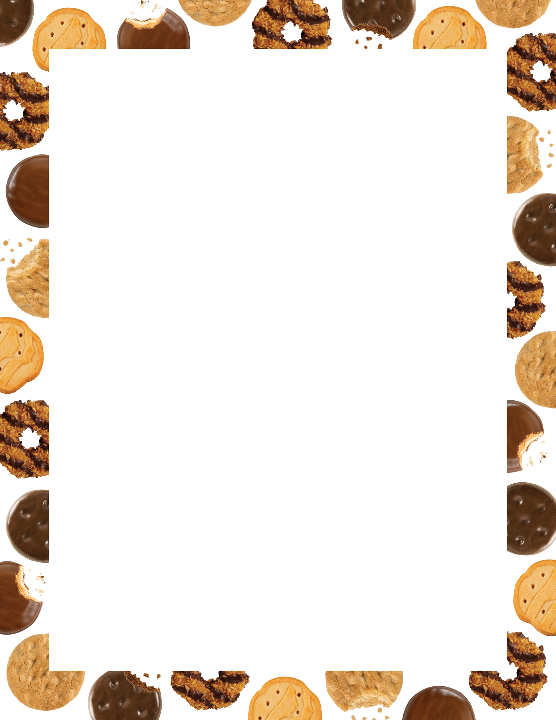

**TK Kindness Cookie Challenge**

**What is the “TK Kindness Cookie Challenge?”**

“Rule #5-This is our favorite rule. This is the most important rule: Be kind to myself and others.”-TK

In an effort to support two of my former TK kiddos’ Girl Scout Troops and Love On Your Back, I thought the families on LOYB might like a sweet treat in their backpacks. I also thought it would be a perfect opportunity to get our TK kiddos involved in spreading the LOVE and KINDNESS, too!

**For every 10 acts of kindness completed on your child’s Kindness Chart, I will donate a box of cookies to a family on LOYB.** There are 53 families on LOYB. If each of our kiddos does 30 acts of kindness (plus I complete 30 acts myself), we will have given EVERY family a box of cookies...with one box to spare. That’s 540 acts of kindness <3 While 30 is the minimum acts of kindness per kiddo to reach our goal, I encourage us all to do more! ☺ As a fun incentive, **\*the kiddo who does the MOST acts of kindness will earn a box of cookies…along with another SPECIAL surprise as well ☺**

**Directions:**

1. **KINDNESS CHART**

Attached is a pre-filled out chart. Have your child color in each box of kindness that they perform, and fill in their own kindness acts in the blank spaces. I’ve also included a blank chart for them to perform more kind acts, which I HIGHLY encourage ☺ Remember, even a SMILE can be an act of kindness ☺

1. **PICTURES OF KINDNESS :)**

**Have your child draw THREE pictures(s) and/or include a photo(s) of themselves performing a kind act(s).** ☺ They are encouraged to make/take more pictures than the recommended three (we have 53 bags to fill!) I am sure the families would love and appreciate their artwork and/or photos!

**Due Date:**

**Please email or turn in their Kindness Chart and artwork/photos NO LATER than MONDAY, FEBRUARY 22.** LOYB puts the backpacks together on Tues. Feb 23 to be distributed on FEBRUARY 24. This would give the kiddos this week and the week off to do their acts of kindness.

Once the cookies arrive, I plan on having the kiddos decorate brown paper bags to put the cookies in along with a note explaining our project, a kindness chart of the families’ own to fill-out (to keep spreading the ripple effects of kindness), and the artwork/pictures from the kiddos.

I am excited about this project and giving our TK kiddos an opportunity to serve. I think it’s essential to not only teach compassion, empathy, kindness, love, and giving but to MODEL and TAKE ACTION <3

*Remember

We do kind acts out of the goodness of our hearts. We call this doing it for INTRINSIC value, meaning from WITHIN ourselves. It makes our heart feel good <3 So, keep spreading the LOVE and kindness ☺

Limitless Love,

Miss Fiscus

“No act of kindness, no matter how small, is ever wasted.”-Aesop

x