**Kindergarten Playground Rules**

1. ONLY **BOTTOMS DOWN** the slide **ONE** (child) **AT A TIME**

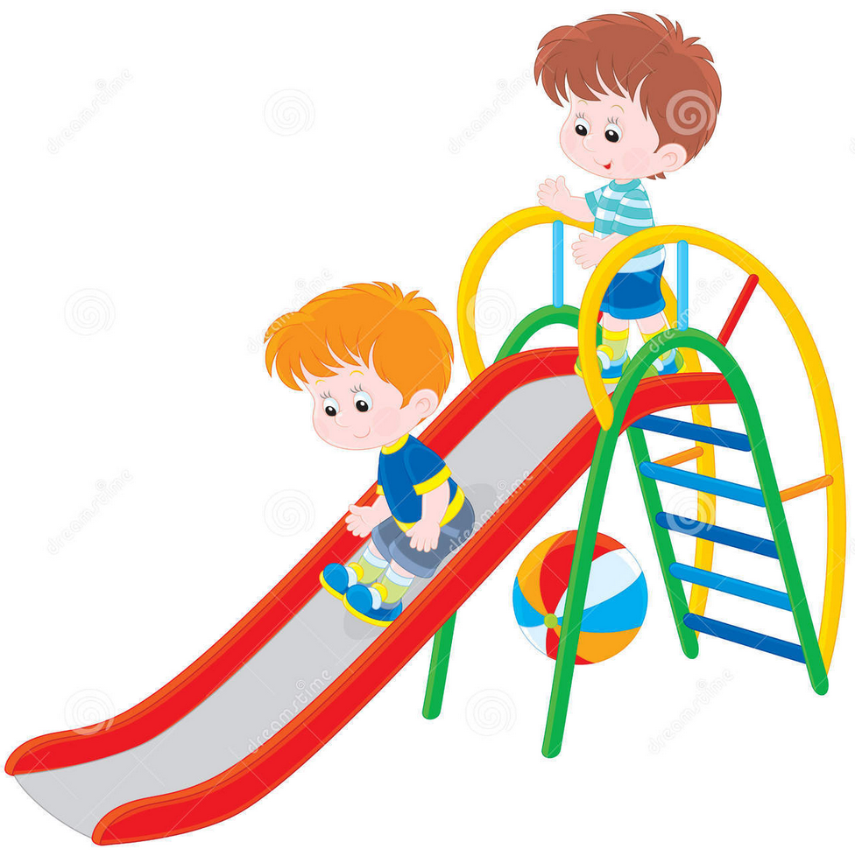

1. ONLY feet **UP THE STAIRS**

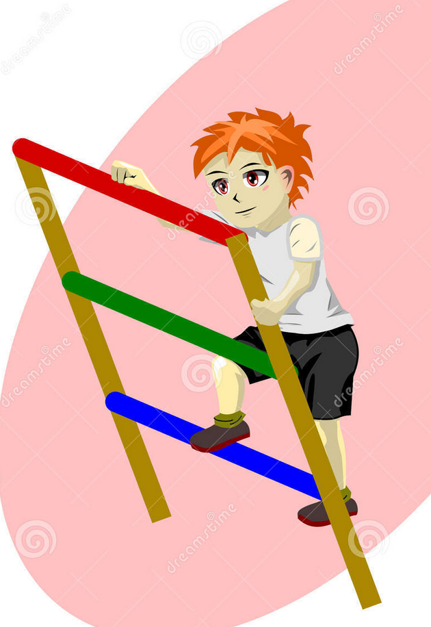

1. ONLY **RUN** on the **GRASS**

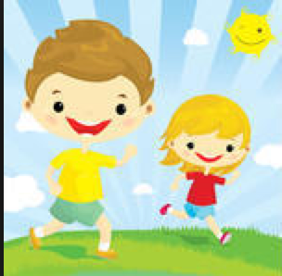

1. 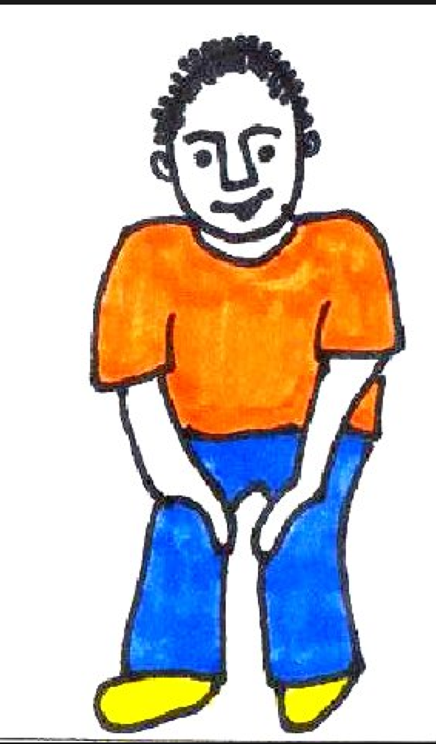**WHISTLE** BLOWS **HANDS** on **KNEES**  **FREEZE!**

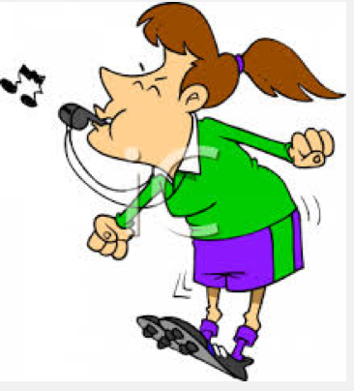

1. **LOOK** and **WALK** to line

