Rule #1

LISTEN when others
are speaking.

Rule #2



Follow directions
the FIRST time.

Rule #3

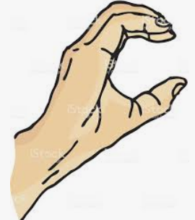
?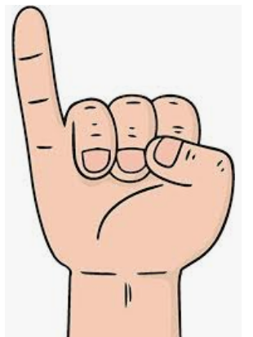?
Question
Comment
(Share)
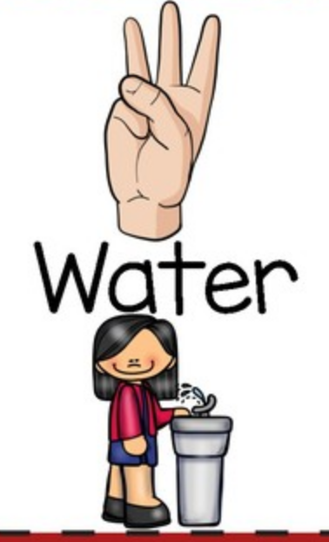
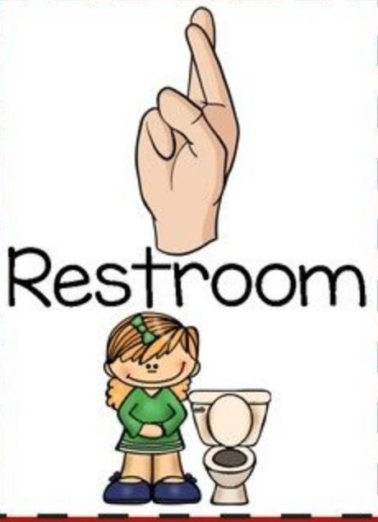


To Cubby
Raise a SILENT hand to speak or leave my seat…

or CHEER!
(Silent Cheer – “spirit” fingers) ☺
Rule #4
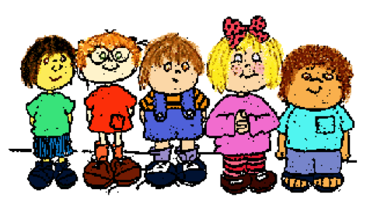

Keep my hands,
feet, objects, and
HURTFUL words to myself.
Rule #5



BE KIND to myself
and others ☺

